**Introduction** - Implement a method for reddit that traverses and processes the comments and returns a value from 0 to 1 between positive, negative, and neutral comments. Using reddit API with machine learning through reddit threads and their URL’s we are recursively checking the voting system in reddit and determining if they are positive, negative, and neutral comments.

**Proposed solution design and implementation** - I first wrote a method that recursively went through the comments, but it would only go through the first comments made in the thread and not their replies. I then later rewrote it and made sure to include layers of replies from the first replies second and so forth. The hard part at least for me was making sure to implement the three methods that were included in the code provided. At first the code would return all three values for each reply which would be a lot of results so instead I made it return the highest value of the three with each corresponding comment. The process_comments method was changed the most in which I made it into a list so that the comments can be printed for later. For the replies I gave them a rank and using a for loop and using maximum I was able to get the highest score of each comment and reply.

**Experimental results** -

I first tested on the URL provided on the code to make sure it worked.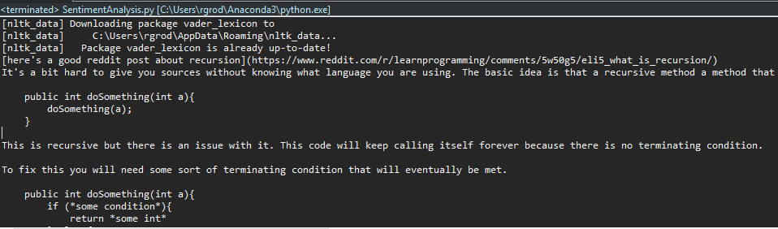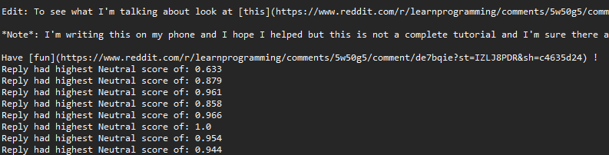

Then I tested on different subreddits with different opinions to check the change.

<https://www.reddit.com/r/aww/comments/9gmx0p/pawception/>

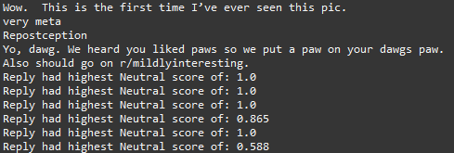

<https://www.reddit.com/r/funny/comments/9gq6k6/what_if/>

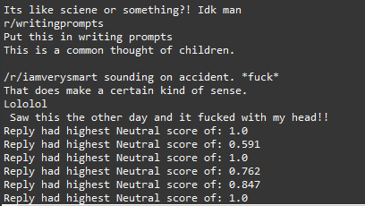

<https://www.reddit.com/r/movies/comments/7ituw9/the_foreigner_was_brutal/>

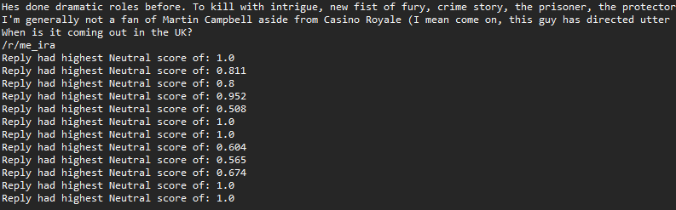

**Conclusion** - I learned a bit of machine learning and how its able to interact with reddit a site I use frequently. I had to think of different ways of implementing each method so that I could get the result I wanted. Using recursion on reddit comments was never a thought of mine and know I can see how each reply to a comment is like a tree and be used to test computer science.

**Source code** -

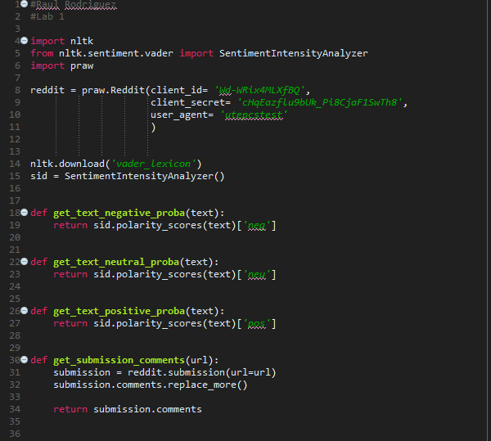

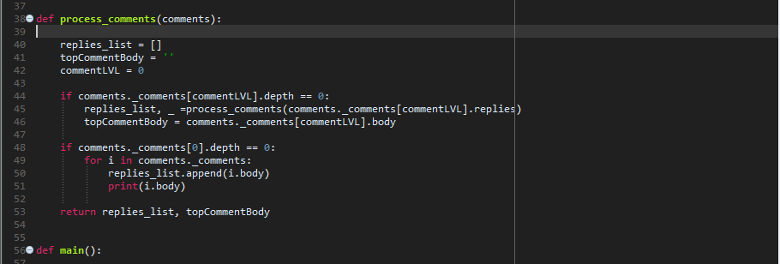

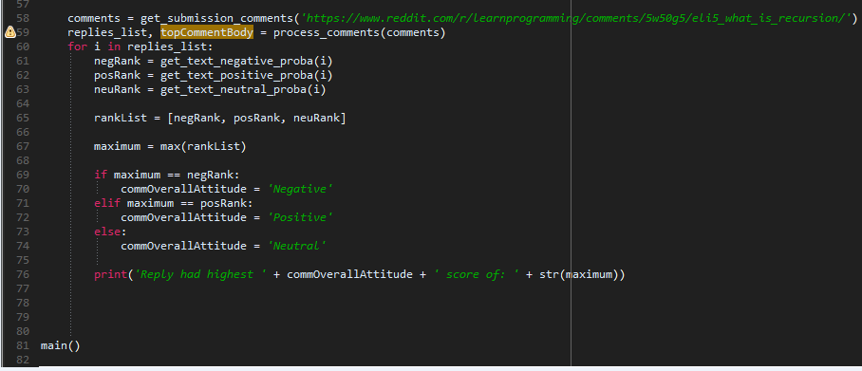

“I certify that this project is entirely my own work. I wrote, debugged, and tested the code being presented, performed the experiments, and wrote the report. I also certify that I did not share my code or report or provided inappropriate assistance to any student in the class.”